**Executive Summary: Big Mountain Resort**

Big Mountain Resort has the potential to increase its revenue by increasing its ticket prices from the current price of $81 to $95.87, which is in line with the predicted value from our model. Our analysis of the Big Mountain Resort dataset suggests that this change can help cover the additional operating cost of the new chair lift. However, there are some limitations to our analysis, including the lack of cost information on other factors such as labor, utilities, and maintenance. Nevertheless, our model can be used to test different scenarios and make informed decisions about pricing and operations.

**Introduction**

Big Mountain Resort is a popular ski resort that is located in the Northern Rockies of Montana. The resort offers a variety of activities and amenities, including skiing, snowboarding, and lodging. In recent years, the resort has invested in several improvements, including a new chair lift that provides access to more terrain.

However, with these improvements come additional costs, and the resort is faced with the challenge of increasing revenue to cover these costs. Our analysis and modeling of the resort's data aims to provide recommendations that can help the resort achieve this goal.

**Data Wrangling**

Our original dataset included 330 rows and 27 columns which did include our Big Mountain Resort Data. By the end of our data wrangling session we trimmed our dataset to 277 rows and 25 columns. This was done by adding some state specific information in order to compare resorts to the rest of their state as well as dropping some useless columns such as fast eight which had only one non-zero value.

As the goal of our test was to predict ticket prices we removed all rows with no available pricing information and then removed the weekday pricing as there were less missing adult weekend ticket prices.

**Analysis and Recommendations**

Our analysis of the Big Mountain Resort dataset suggests that the resort should increase its ticket prices from the current price of $81 to $95.87, which is in line with the predicted value from our model. This change is expected to result in increased revenue for the resort, which can help cover the additional operating cost of the new chair lift.

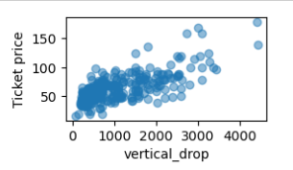

Figure1

Figure 1 above shows a positive correlation between vertical drop and ticket price. Similar charts were created for all potential features against ticket prices during the EDA stage and this gave us an idea of what the most impactful features may be.

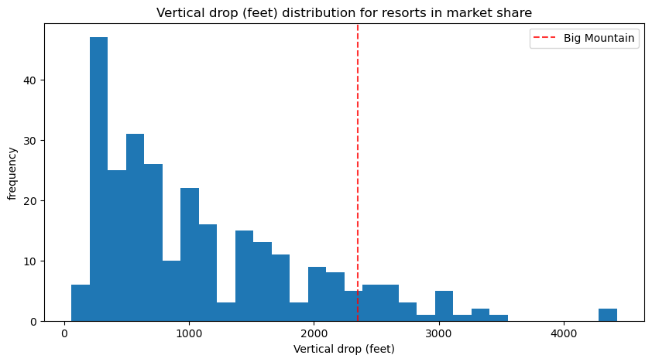

Figure2

We also found that Big Mountain Resort was ranked fairly high on some of the league charts of facilities offered, but the modeled price was much higher than the current price. This mismatch may come as a surprise to the business executives, and it would be important to find out their thoughts on the model and its recommendations. Figure 2 above shows an example of how Big Mountain Resort compares to other resorts in the most important predictive features.

**Preprocessing and Training**

During our Preprocessing and Training stage we developed a machine learning model to predict ticket prices for ski resorts. Through the process we found that the best preprocessing steps were determined to be imputation using the median, scaling the features, and selecting the best features using SelectKBest. The performance of this model was also evaluated using cross-validation and a test split. Ultimately the random forest regressor was selected as the model of choice going forward due to its higher accuracy and consistency in performance on both the cross-validation and test sets.

**Conclusion**

If the business leaders find the model useful, we recommend that they use it to test new combinations of parameters in different scenarios to see how they affect revenue and profitability. The model can be made available for business analysts to use and explore, allowing them to make informed decisions about pricing and operations.

In conclusion, our analysis suggests that increasing ticket prices to $95.87 can help increase revenue for Big Mountain Resort, but it is important to gather more cost information to refine the model and make more accurate recommendations. The resort can use the model to test different scenarios and make informed decisions about pricing and operations.